**To Supply Leftover**

**Food to Poor**

## By

**Yambadi Tejaswar**

yambaditejaswar2004@gmail.com

## PROJECT ABSTRACT

Food waste is a significant issue worldwide, with tons of food being discarded daily while many people suffer from hunger. This project aims to develop a Salesforce-based solution to streamline the process of collecting and distributing leftover food to those in need. By leveraging the capabilities of Salesforce, we can efficiently manage the logistics, ensure food safety, and maximize the impact of food donations.

This project will minimize food waste by redirecting surplus food to the poor, ensuring timely and efficient distribution. It will also enhance transparency through real-time tracking and reporting of food donations and distributions. Additionally, the project will engage volunteers and donors, facilitating their involvement in the food redistribution process.

The methodology involves integrating Salesforce CRM to create a centralized system for managing food donations, donors, volunteers, and beneficiaries. A portal will be developed for food establishments to register and report surplus food. Volunteers will be coordinated through a registration and assignment module to ensure efficient food pick-up and delivery. A system will be implemented for identifying and registering individuals and communities in need of food assistance. Logistics management will be optimizedusing Salesforce's capabilities, and real-time trackingwill be enabled through Salesforce's reporting and dashboard features. A feedback mechanism will be incorporated to continuously improve the process.

Expected outcomes includea significant reductionin food waste from participating establishments, improved food access for needy individuals and communities, higher participation rates from volunteers and donors, and clear and transparent reporting of all activities related to food collection and distribution. This Salesforce- based project addresses the dual issues of food waste and hunger by creating an efficient system for redistributing leftover food. By leveraging Salesforce's robust features,the project aims to create a sustainable and scalable solution that can be adopted by communities worldwide.

## 

## INDEX PAGE

|  |  |
| --- | --- |
| Topics | Page no |
| Salesforce Developer Account Creation | 5 |
| Objects creation | 7 |
| Tabs | 12 |
| The Lightning App | 13 |
| Fields creation | 16 |
| Flows | 32 |
| Trigger | 35 |
| Profiles | 37 |
| Creation of Users | 38 |
| Public Groups | 40 |
| Report Types | 42 |
| Reports | 43 |
| Dashboards | 45 |
| Sharing Rules | 48 |
| Home Page | 50 |

**INTRODCTION**

Food waste is a growing concern globally, with an alarming amount of edible food being discarded daily while millions of people suffer from hunger and food insecurity. This paradox highlights the need for innovative solutions to bridge the gap between surplus food and those in need. The project "Supply Leftover Food to the Poor" aims to address this issue by leveraging the powerful capabilities of Salesforce to create a streamlined, efficient, and scalable system for collecting, managing, and distributing leftover food.

The core idea is to develop a centralized platform where restaurants, cafes, and other food establishments can easily report their surplus food. Volunteers can then be coordinated to collect and deliver this food to registered beneficiaries, ensuring that the food reaches those in need promptly and safely. By using Salesforce's CRM tools, we can enhance the efficiency of this process, track real-time data, and maintain transparency throughout the operation.

This project not only aims to reduce food waste but also seeks to improve food security for disadvantaged individuals and communities. Through community engagement and leveraging technology, we can create a sustainable model that benefits both the environment and society. By addressing logistical challenges and ensuring proper food handling and distribution, this project hopes to set a precedent for how technology can be used to tackle pressing social issues.

## TASK 1: Salesforce developer account creation

### Creating Developer Account

Creating a developer org in salesforce.

1. 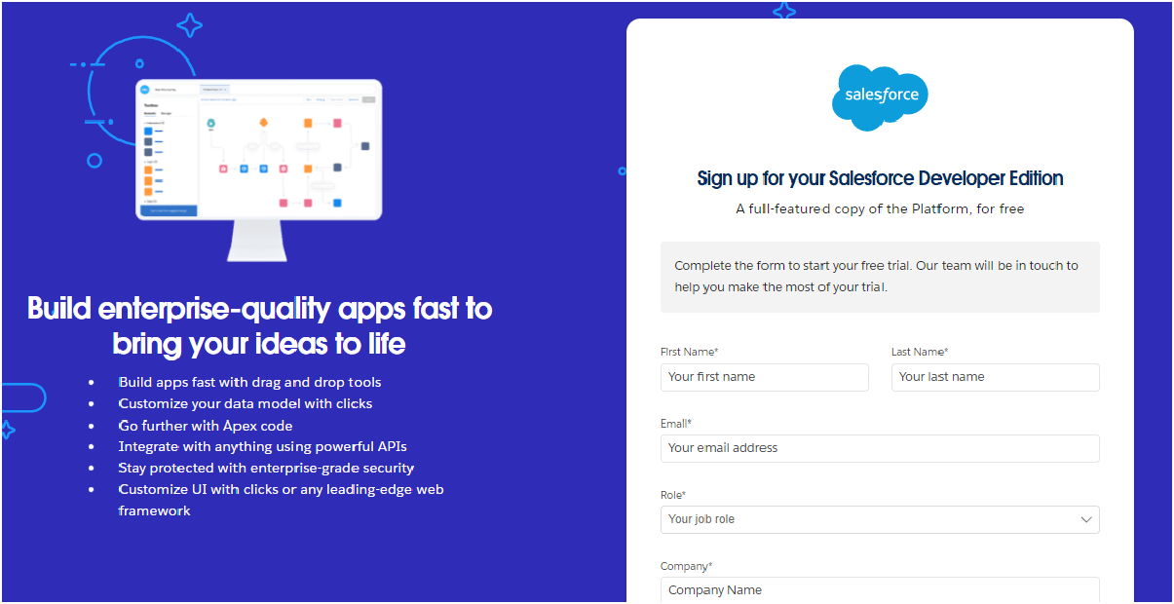Go to <https://developer.salesforce.com/signup>
2. On the sign up form, enter the following details :

|  |  |
| --- | --- |
|  |  |
|  |  |

1. On the sign up form, enter the following details :
   1. First name & Last name
   2. Email
   3. Role : Developer
   4. Company : College or Company Name
   5. County : India
   6. Postal Code : pin code
   7. Username : should be a combination of your name and companyThis need not be an actual email id, you can give anything in the format : [username@organization.com](mailto:username@organization.com)

Click on sign me up after filling these.

### Account Activation

1. Go to the inbox of the email that you used while signingup. Click on the verify

|  |  |
| --- | --- |
|  |  |
|  |  |

account to activate your account. The email may take 5-10mins.

Click on VerifyAccount

2 . Give a password and answer a security questionand click on change password.

1. Give a password and answer a security questionand click on change password.

|  |  |
| --- | --- |
|  |  |
|  |  |

1. Then you will redirect to your salesforce setup page.

## TASK 2: Objectscreation

### Create Venue Object

To create an object:

1. From the setuppage >> Clickon Object Manager>> Click on Create >>Click on Custom Object.

1. Enter the label name >> Venue
2. Plural labelname >> Venues
3. Enter RecordName Label and Format
4. Record Name >> VenueName
5. Data Type >> Text
6. Click on Allow reports and Track Field History,Allow Activities.
7. Allow search >> Save.

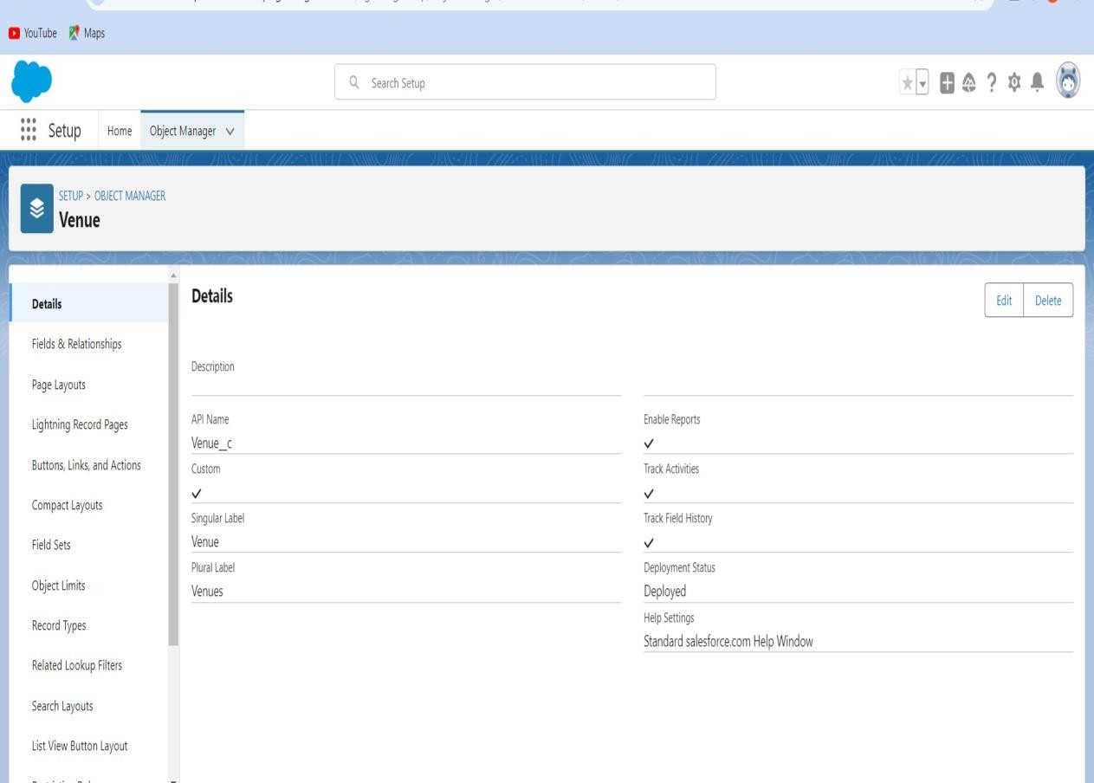

### Create Drop-Off Point Object

To create an object:

1. From the setup page >>Click on ObjectManager >> Click on Create >> Click on CustomObject.

1. Enter the label name >> Drop-OffPoint
2. Plural label name>> Drop-Off Points
3. Enter RecordName Label and Format
4. Record Name >> Drop-Off point Name
5. Data Type >> Text
6. Click on Allow reports and Track Field History,Allow Activities
7. Allow search >> Save.

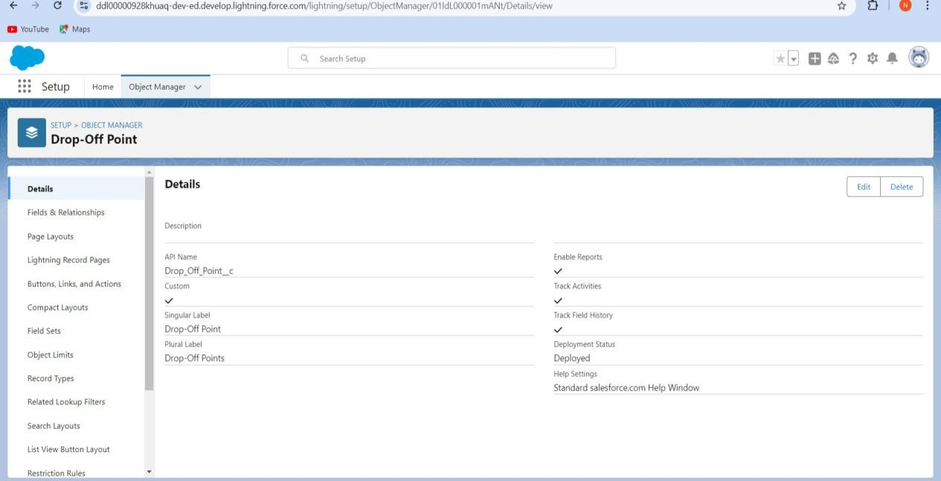

### Create Task Object

To create an object:

1. From the setup page >>Click on ObjectManager >> Click on Create >> Click on CustomObject.

1. Enter the label name>> Task
2. Plural label name>> Tasks
3. Enter RecordName Label and Format
4. Record Name >> TaskName
5. Data Type >> Text
6. Click on Allow reports and Track Field History,Allow Activities
7. Allow search >> Save.

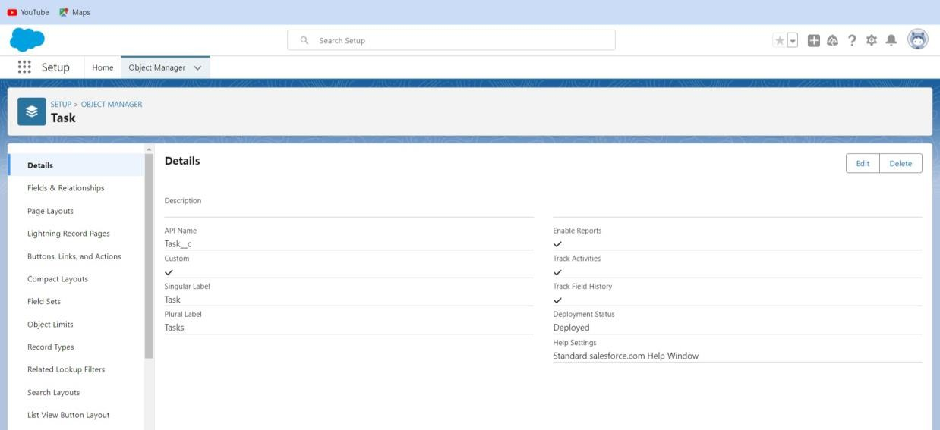

### Create Volunteer Object

To create an object:

1. From the setup page >>Click on ObjectManager>> Click on Create >>Click on CustomObject.

1. Enterthe label name>> Volunteer
2. Plural label name>> Volunteers
3. Enter RecordName Label and Format
4. Record Name >> Volunteer Name
5. Data Type >> Text
6. Click on Allow reports and Track Field History, AllowActivities
7. Allow search >> Save

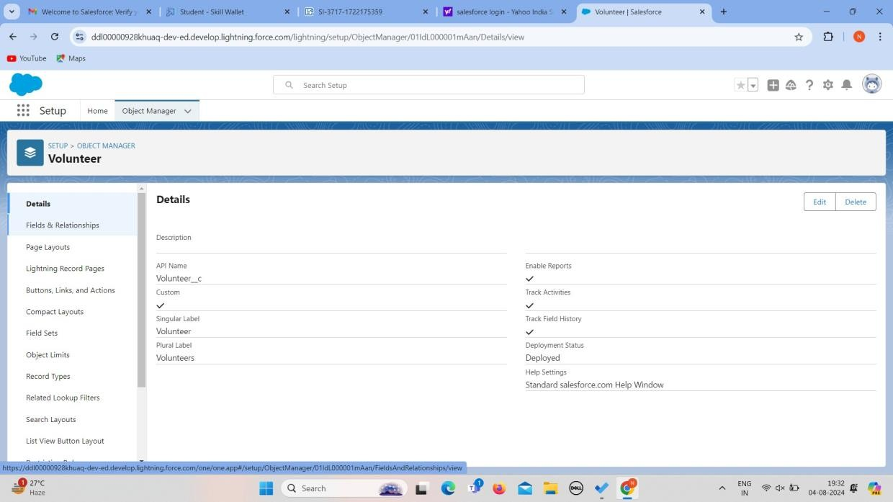

### Create Execution DetailsObject

To create an object:

1. From the setup page >> Click on ObjectManager >> Click on Create >> Click on CustomObject.

1. Enter the labelname >> ExecutionDetail
2. Plural label name >> Execution Details
3. Enter Record Name Label and Format
4. Record Name >> Execution Detail Name
5. Data Type >> Text
6. Click on Allow reports and Track Field History, Allow Activities
7. Allow search >> Save.

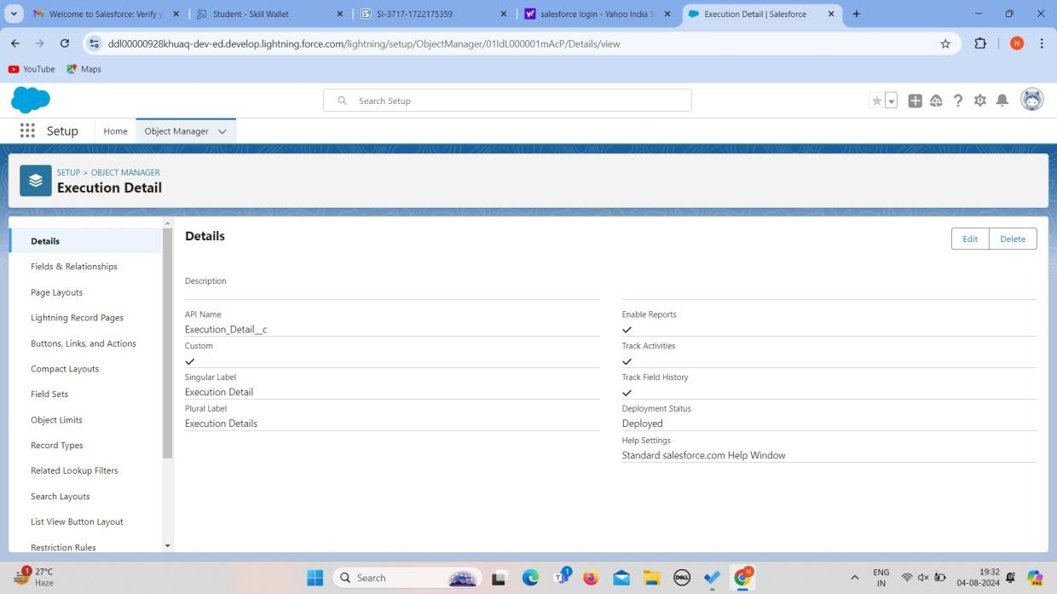

## TASK 3: Tabs

What is Tab : A tab is like a user interface that is used to build records for objects and to view the records in the objects.

### Creating a Custom Tab

To create a Tab:(Venue)

Go to setup page >>type Tabs in Quick Find bar >>click on tabs >> New (under customobject tab)

1. Select Object(Venue) >> Select the tab style >> Next (Add to profiles page) keep it as default >> Next (Add to Custom App) uncheck the includetab .
2. Make sure that the Appendtab to users' existing personalcustomizations is checked.
3. Clicksave

### Creating Remaining Tabs

1. Now create the Tabs for the remainingObjects, they are “Drop-Off Point,Task, Volunteer, Execution Details”.
2. Follow the same steps as mentionedin above Activity.

|  |  |
| --- | --- |
|  |  |
|  |  |

# TASK 4: The LightningApp

### To create a lightning app page:

1. Go to setup page >> search“app manager” in quick find >> select“app manager” >>click on New lightning App.

1. Fill the app name in app details and branding as follow App Name : FoodConnect

Developer Name : This will auto populated

Image : optional (if you want to give any image you can otherwise not mandatory) Primarycolor hex value :keep this default.

1. Then click Next >> (App option page)SetNavigation Style as Standard Navigation >> Next.

1. (Utility Items) keep it as default>> Next.
2. To Add Navigation Items:

Search for the item in the (Home, Venue, Drop-Off Point, Task, Volunteer, Execution Details, Reports) from the searchbar and move it using the arrow button >>Next >> Next.

1. To Add User Profiles:

Search profiles (System administrator) in the search bar >> click on the arrow button>> save & finish.

|  |  |
| --- | --- |
|  |  |
|  |  |

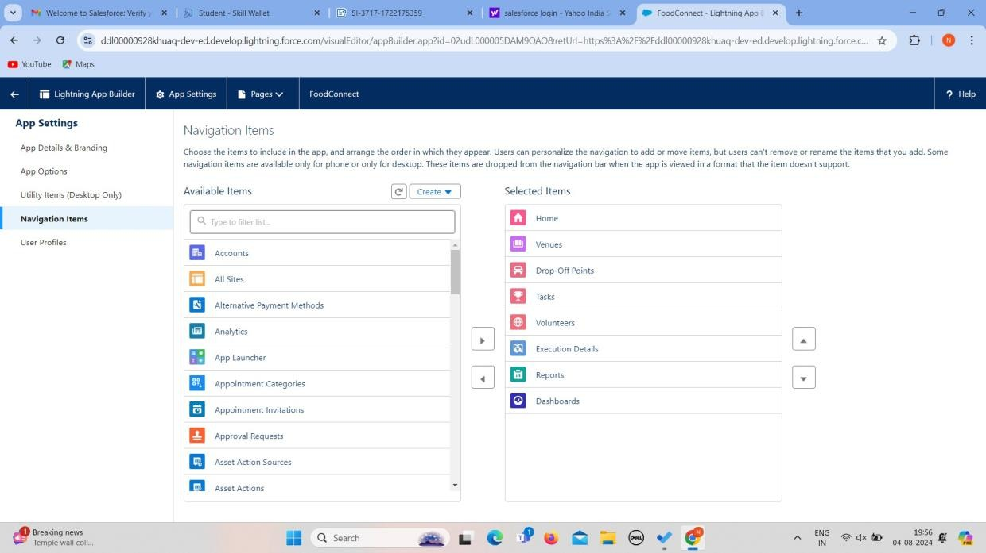

|  |  |
| --- | --- |
|  |  |
|  |  |

**TASK 5: Fieldscreation**

Creation of Relationship fieldsin objects

#### Creation of Lookup Relationship Field on VolunteerObject :

1. Go to setup >>click on ObjectManager >> type object name(Volunteer) in the searchbar >> click on the object.
2. Now click on “Fields & Relationships” >>New
3. Select Master Detail relationship
4. Select the related object “Drop-Off point” and click next.
5. FieldName : Drop_Off_point
6. Fieldlabel : Auto generated
7. Next>> Next >>Save.

#### Creation of Master DetailRelationship Field on Execution DetailsObject :

1. Go to setup >>click on ObjectManager >> type object name(Execution Details) in the searchbar >> click on the object.
2. Now click on “Fields & Relationships” >>New
3. Select Master Detail relationship
4. Select the related object “Volunteer” andclick next.
5. Field Name : Volunteer
6. Fieldlabel : Auto generated
7. Next >>Next >> Save.

#### Creation of MasterDetail Relationship Field on ExecutionDetails Object :

1. Go to setup>> click on Object Manager>> type object name(Execution Details) in the search bar >> click on the object.
2. Now click on “Fields & Relationships” >>New

1. Select Master Detail relationship
2. Select the related object “Task” and click next.
3. FieldName : Task
4. Field label : Auto generated
5. Next>> Next >>Save.

#### Creation of Lookup Relationship Field on Drop-OffPoint Object :

1. Go to setup>> click on Object Manager>> type object name(Task) in the searchbar >> click onthe object.
2. Now click on “Fields & Relationships” >>New
3. Select Lookup relationship
4. Select the related object “Drop-Off Point” and click next.
5. FieldName : Venue
6. Field label : Venue c
7. Next>> Next >>Save.

#### Creation of Lookup Relationship Field on Task Object :

1. Go to setup>> click on ObjectManager >> type object name(Task) in the searchbar >> click on the object.
2. Now click on “Fields & Relationships” >>New
3. Select Lookup relationship
4. Select the related object “Venue” and click next.
5. FieldName : Sponsored By
6. Fieldlabel : Auto generated
7. Next >>Next >> Save.

#### Creation of LookupRelationship Field on Task Object:

1. Go to setup>> click on ObjectManager >> type object name(Task) in the searchbar >> click on the object.
2. Now click on “Fields & Relationships” >>New
3. Select Lookup relationship
4. Select the related object “Drop-Off point” and click next.
5. Field Name : Drop-Off point
6. Fieldlabel : Auto generated
7. Next>> Next >>Save.

**Creation of fieldsfor the Venue object**

1. Go to setup>> click on ObjectManager >> type object name(Venue) in search bar >> clickon the object.
2. Now click on “Fields & Relationships” >>New
3. Select Data type as a “Email”and Click on Next
4. Fill the Aboveas following:
5. FieldLabel : ContactEmail
6. FieldName : Contact Email
7. Click on required checkbox
8. Clickon Next >> Next >>Save and new.

#### Tocreate another fields in an object:

1. Go to setup >>click on ObjectManager >> type object name(Venue) in search bar >> clickon the object.
2. Now click on “Fields & Relationships” >>New
3. Select Data type as a “Phone”and Click on Next
4. Fill the Aboveas following:
5. FieldLabel : Contact Phone
6. FieldName : Contact Phone
7. Click on required checkbox

1. Clickon Next >> Next >>Save and new.

#### Tocreate another fields in an object:

1. Go to setup >>click on ObjectManager >> type object name(Venue) in search bar

>>click on the object.

1. Now click on “Fields &Relationships” >> New
2. Select Data type as a “Geolocation” andClick on Next
3. Fill the Above as following:
4. FieldLabel : Location
5. Decimal Places : 4
6. FieldName : Location
7. Description : Enter the Geolocation of your Venue
8. Clickon Next >> Next >>Save and new.

#### Tocreate another fields in an object:

1. Go to setup >>click on ObjectManager >> type object name(Venue) in search bar >> clickon the object.
2. Now click on “Fields &Relationships” >> New
3. Select Data type as a “Long Text Area” and Click on Next
4. Fill the Above as following:
5. FieldLabel : Venue Location
6. FieldName : Venue_Location
7. Clickon Next >> Next >>Save and new.

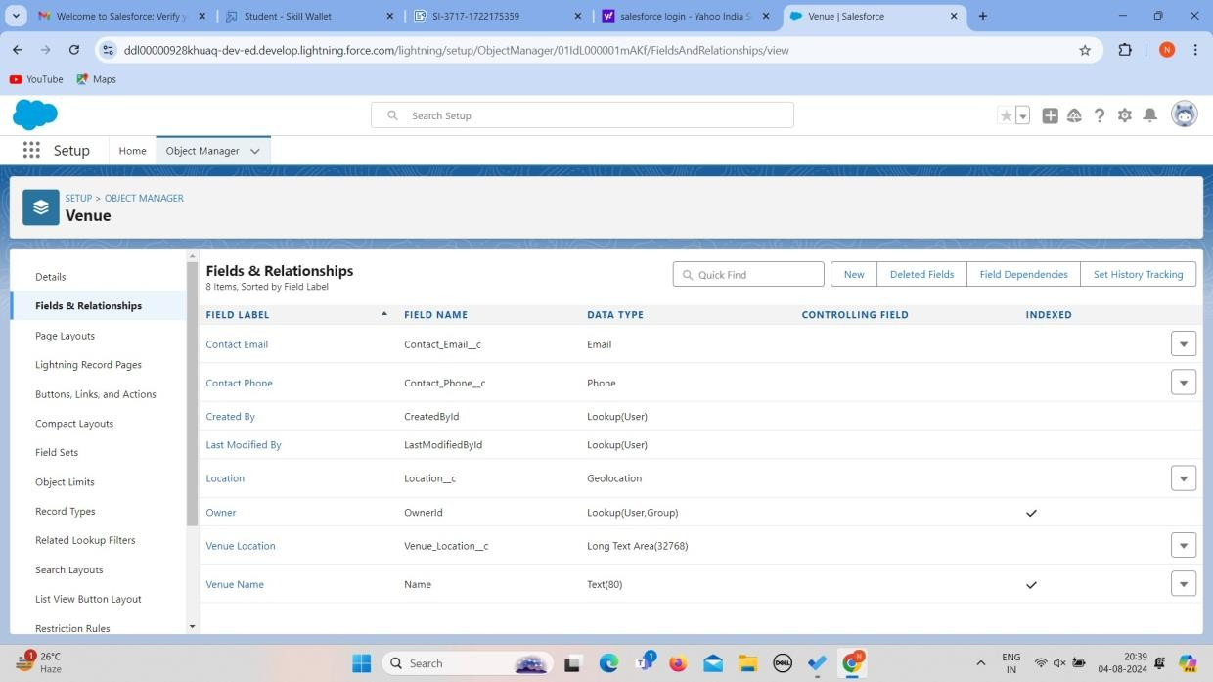

### Creation of fields for the Drop-Off point object

Go to setup >> clickon Object Manager>> type object name(Drop-Off point) in search bar

>> click on theobject.

1. Now click on “Fields & Relationships” >> New
2. Select Data type as a “Geolocation” andClick on Next
3. Fillthe Above as following:
   1. FieldLabel : Location2
   2. FieldName : gets auto generated
   3. Description : Enter the Geolocation of the Drop off Point
   4. Geolocation Options : select Decimal
   5. Decimal Places : 4
   6. Clickon Next >> Next >>Save and new.

#### Tocreate another fields in an object:

1. Go to setup >> click on Object Manager >> type object name(Drop-Off point)in

search bar >>click on the object.

1. Now click on “Fields & Relationships” >>New
2. Select Datatype as a “Formula” and Click on Next
3. Fillthe Above as following:
   1. Field Label : distance calculation
   2. Field Name : distance_calculation
   3. Formula Return Type : Number
   4. Formula Options : DISTANCE(Location_2 c , Venue r.Location c , 'km')
   5. Clickon Next >> Next >>Save and new.

#### Tocreate another fields in an object:

1. Go to setup >>click on ObjectManager >> type object name(Drop-Off point) in searchbar >> click on the object.
2. Now click on “Fields & Relationships” >>New
3. Select Data type as a “Picklist” and Click on Next
4. Fillthe Above as following:
   1. FieldLabel : State
   2. FieldName : State
   3. Enter values, with each value separated by a new line : Andhra Pradesh

Arunachal Pradesh Assam

Bihar Chhattisgarh Goa Gujarat

Haryana HimachalPradesh

Jharkhand Karnataka Kerala

Maharashtra Madhya Pradesh Manipur Meghalaya

Mizoram Nagaland Odisha Punjab Rajasthan Sikkim

Tamil Nadu Tripura Telangana Uttar Pradesh

Uttarakhand West Bengal

Andaman & Nicobar (UT) Chandigarh (UT)

Dadra & Nagar Haveli and Daman & Diu (UT) Delhi [National Capital Territory (NCT)] Jammu & Kashmir (UT)

Ladakh (UT)Lakshadweep (UT) Puducherry (UT)

* 1. Click on required checkbox
  2. Clickon Next >> Next >>Save and new.

#### Tocreate another fields in an object:

1. Go to setup >>click on ObjectManager >> type object name(Task) in search bar >> clickon the object.
2. Now click on “Fields &Relationships” >> New

1. Select Data type as a “Number”and Click on Next
2. Fillthe Above as following:
   1. FieldLabel : Distance
   2. FieldName : Distance
   3. Length : 14
   4. Decimal Places : 4
   5. Click on required checkbox
   6. Clickon Next >> Next >>Save and new.

|  |  |
| --- | --- |
|  |  |
|  |  |

### Creation of fieldsfor the Task object

Go to setup>> click on ObjectManager >> type object name(Task) in search bar >> click on the object.

1. Now click on “Fields & Relationships” >> New
2. Select Data type as a “Auto Number” and Click on Next
3. Fillthe Above as following:

* 1. Field Label : Task ID
  2. Display Format : TASK-{0}
  3. Starting Number : 1
  4. FieldName : gets auto generated
  5. Click on required checkbox
  6. Clickon Next >> Next >>Save and new.

#### Tocreate another fields in an object:

1. Go to setup >>click on ObjectManager >> type object name(Task) in search bar >> clickon the object.
2. Now click on “Fields & Relationships” >>New
3. Select Data type as a “Date”and Click on Next
4. Fillthe Above as following:
   1. FieldLabel : Date
   2. FieldName : Date
   3. Click on required checkbox
   4. Clickon Next >> Next >>Save and new.

#### Tocreate another fields in an object:

1. Go to setup >>click on ObjectManager >> type object name(Task) in search bar >> clickon the object.
2. Now click on “Fields & Relationships” >>New
3. Select Data type as a “Picklist (Multi-Select)” and Click on Next
4. Fill the Aboveas following:
   1. FieldLabel : Food Category
   2. FieldName : Food Category
   3. Enter values, with each value separated by a new line : Veg Non-Veg

Salad Snack

* 1. Click on required checkbox
  2. Clickon Next >> Next >>Save and new.

#### Tocreate another fields in an object:

1. Go to setup >>click on ObjectManager >> type object name(Task) in search bar >> clickon the object.
2. Now click on “Fields &Relationships” >> New
3. Select Data type as a “Number”and Click on Next
4. Fill the Above as following:
   1. FieldLabel : Number of PeopleServed
   2. Field Name : Number_of_People_Served
   3. Click on required checkbox
   4. Clickon Next >> Next >>Save and new.

#### Tocreate another fields in an object:

1. Go to setup >>click on ObjectManager >> type object name(Task) in search bar >> clickon the object.
2. Now click on “Fields &Relationships” >> New
3. Select Data type as a “Text”and Click on Next
4. Fillthe Above as following:
   1. FieldLabel : Name of the Person
   2. FieldName : Name_of_the_Person
   3. Clickon Next >> Next >>Save and new.

#### Tocreate another fields in an object:

1. Go to setup>> clickon Object Manager>> type objectname(Task) in searchbar >> click on the object.
2. Now click on “Fields &Relationships” >> New
3. Select Data type as a “Phone”and Click on Next
4. Fillthe Above as following:
   1. FieldLabel : Phone

* 1. FieldName : Phone
  2. Clickon Next >> Next>> Save and new.

#### To createanother fields in an object:

1. Go to setup >>click on ObjectManager >> type object name(Task) in search bar >> clickon the object.
2. Now click on “Fields &Relationships” >> New
3. Select Data type as a “Pick List” and Click on Next
4. Fill the Above as following:
   1. FieldLabel : Rating
   2. FieldName : Rating
   3. Enter values, with each value separated by a new line : 1 2

3

4

5

* 1. Clickon Next >> Next >>Save and new.

#### To createanother fields in an object:

1. Go to setup >>click on ObjectManager >> type object name(Task) in search bar >> clickon the object.
2. Now click on “Fields & Relationships” >>New
3. Select Data type as a “Long Text Area” and Click on Next
4. Fillthe Above as following:
   1. Field Label: Feedback
   2. FieldName : Feedback
   3. Clickon Next >> Next >>Save and new.

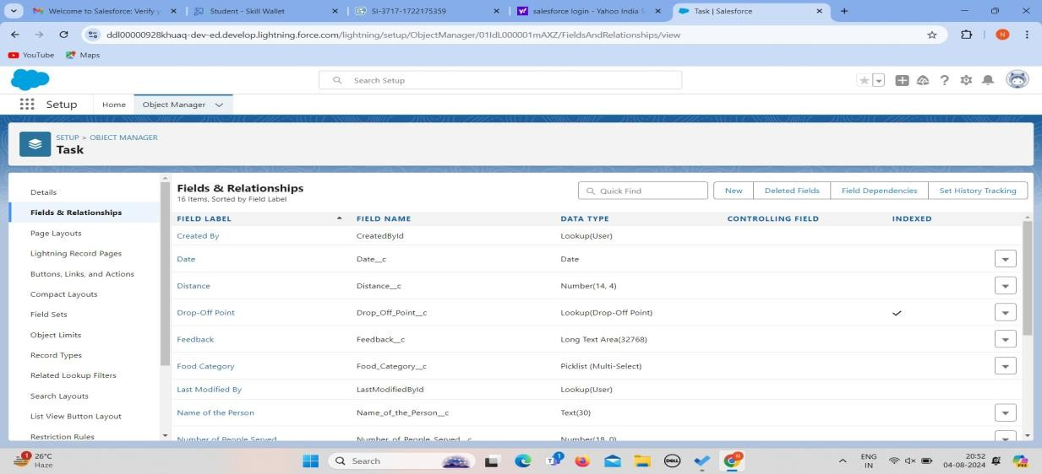

|  |  |
| --- | --- |
|  |  |
|  |  |

### Creation of fieldsfor the Volunteerobject

1. Go to setup >>click on ObjectManager >> type object name(Volunteer) in search bar >> click on the object.

1. Now click on “Fields & Relationships” >> New
2. Select Data type as a “Auto Number” and Click on Next
3. Fillthe Above as following:
   1. Field Label: Volunteer ID
   2. FieldName : gets auto generated
   3. Click on required checkbox
   4. Clickon Next >>Next >> Save and new.
   5. Clickon Next >>Next >> Save and new.

#### To create anotherfields in an object:

1. Go to setup >>click on ObjectManager >> type object name(Volunteer) in search bar >> click on the object.
2. Now click on “Fields & Relationships” >>New
3. Select Data type as a “Picklist” and Click on Next
4. Fillthe Above as following:
   1. FieldLabel : Gender
   2. FieldName : Gender
   3. Enter values, with each value separated by a new line : Female

Male

* 1. Clickon Next >> Next >>Save and new.

#### Tocreate another fields in an object:

1. Go to setup >>click on ObjectManager >> type object name(Volunteer) in search bar >> click on the object.
2. Now click on “Fields & Relationships” >>New
3. Select Data type as a “Date”and Click on Next
4. Fillthe Above as following:
   1. Field Label: Available On
   2. FieldName : Available On

* 1. Click on required checkbox
  2. Clickon Next >> Next >>Save and new.

#### To createanother fields in an object:

1. Go to setup >>click on ObjectManager >> type object name(Volunteer) in search bar >> click on the object.
2. Now click on “Fields &Relationships” >> New
3. Select Data type as a “Number”and Click on Next
4. Fill the Above as following:
   1. FieldLabel : Age
   2. FieldName : Age
   3. Click on required checkbox
   4. Clickon Next >> Next>> Save and new.

#### To createanother fields in an object:

1. Go to setup >>click on ObjectManager >> type object name(Volunteer) in search bar >> click on the object.
2. Now click on “Fields &Relationships” >> New
3. Select Data type as a “Email”and Click on Next
4. Fillthe Above as following:
   1. FieldLabel : Email
   2. FieldName : Email
   3. Click on required checkbox
   4. Clickon Next>> Next >> Save and new.

#### Tocreate another fields in an object:

1. Go to setup >>click on ObjectManager >> type object name(Volunteer) in search bar >> click on the object.
2. Now click on “Fields &Relationships” >> New
3. Select Data type as a “Number”and Click on Next
4. Fill the Above as following:

* 1. FieldLabel : ContactNumber
  2. FieldName : Contact_Number
  3. Click on required checkbox
  4. Clickon Next >> Next >>Save and new.

#### Tocreate another fields in an object:

1. Go to setup >>click on ObjectManager >> type object name(Volunteer) in search bar >> click on the object.
2. Now click on “Fields &Relationships” >> New
3. Select Data type as a “TextArea (Long)” and Click on Next
4. Fillthe Above as following:
   1. FieldLabel : Address
   2. FieldName : Address
   3. Clickon Next >> Next >>Save and new.

#### To create anotherfields in an object:

1. Go to setup >>click on ObjectManager >> type object name(Volunteer) in search bar >> click on the object.
2. Now click on “Fields &Relationships” >> New
3. Select Data type as a “Date”and Click on Next
4. Fill the Above as following:
   1. FieldLabel : Date of Birth
   2. FieldName : Date_of_Birth
   3. Clickon Next >> Next >>Save and new.

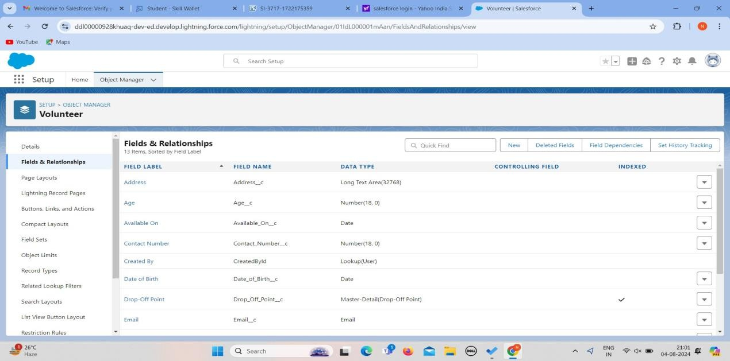

|  |  |
| --- | --- |
|  |  |
|  |  |

### Creation of fieldsfor the Execution Details object

1. Go to setup>> click on Object Manager>> type objectname(Volunteer) in searchbar >> click on the object.
2. Now click on “Fields & Relationships” >>New
3. Select Data type as a “Auto Number” and Click on Next

1. Fill the Above as following:
   1. Field Label: Execution ID
   2. FieldName : gets auto generated
   3. Click on required checkbox
   4. Clickon Next >> Next >>Save and new.

|  |  |
| --- | --- |
|  |  |
|  |  |

## TASK 6: FLOWS

### Create Flow to create a record in Venue object

1. Go to setup >>type Flow in quick find box >>Click on the Flow and Select the New Flow.
2. Select the Screen flow. Clickon create.

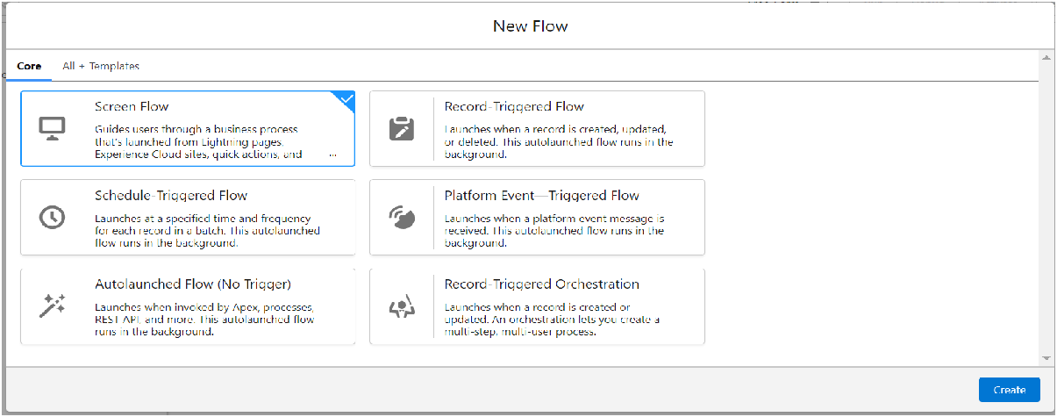

1. Clickon the ‘+’ icon in between start and end, and click on screenelement.
2. Under the Screen Properties: Label : Venue Details

API Name : Venue_Details

1. Now lets add components in this flow. Click on Text Componentand name it as: Label: Venue Name API

Name : Venue_Name

1. Click on Email Componentand name it as: Label: Email

API Name : Contact_Email

1. Click on Phone Component and name it as: Label: Phone

API Name : Contact_Phone

1. Click on Text Component and name it as: Label: Venue Location

API Name : Venue_Location

1. Click on Number Componentand name it as: Label: Latitude

API Name : Latitude

1. Clickon Number Componentand name it as:

Label : longitude API Name : longitude

|  |  |
| --- | --- |
|  |  |
|  |  |

1. Next click on Done. This would like below
2. Click on the ‘+’ icon in between Venue details and end, and click on create recordelement.
3. Now label it as

Label : Create Venue Record API Name : Create_Venue_Record

How Many Records to Create : One

How to Set the Record Fields : Use separate resources, and literalvalues Object : Venue

Set Field Valuesfor the Venue : Click on ‘Add Field’ 5 times Field

: Value = Contact_Email c : {!Contact_Email.value} Field : Value = Contact_Phone c : {!Contact_Phone.value} Field : Value

= Name : {!Venue_Name}

Field : Value = Venue_Location c : {!location}

Field : Value = Location Latitude s : {!latitude} Field : Value = Location Longitude s : {!longitude}

|  |  |
| --- | --- |
|  |  |
|  |  |

1. This would look like:
2. Click on Save as:

Flow Label : Venue Form Flow API Name : Venue_Form

## TASK 7: Trigger

### Create a Trigger

1. Log into the trailhead account, navigate to the gear icon in the top right corner.
2. Click on developer consoleand you will be navigatedto a new console window.
3. Click on the File menu in the toolbar,and click on new >>Trigger.
4. Enter the trigger name and the object to be triggered.

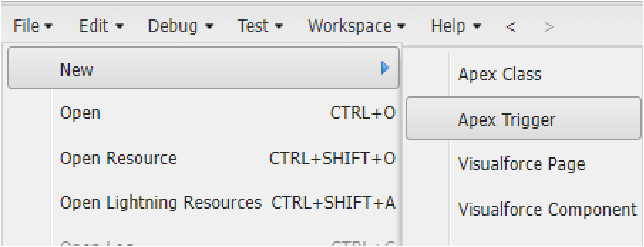

|  |  |
| --- | --- |
|  |  |
|  |  |

1. Enter Name : DropOffTrigger sObject: Drop-OffPoint
2. Click on Submit.

### Trigger Code

(This Trigger is to assign Distance field to the Distance Calculation field. So that wecan assign the distance in the sharing rules.)

#### Code:

trigger DropOffTrigger on Drop_Off_point c (beforeinsert) { for(Drop_Off_point c Drop : Trigger.new){

Drop.Distance c= Drop.distance_calculation c;

}

|  |  |
| --- | --- |
|  |  |
|  |  |

}

## TASK 8: Profiles

1. Go to setup page >> type Profiles in Quick Find bar >>click on Profiles>> click on ‘S’
2. Click on Clone beside StandardPlatform User.
3. Under Clone Profile:

Profile Name : NGOs Profile

1. Then clickon Save

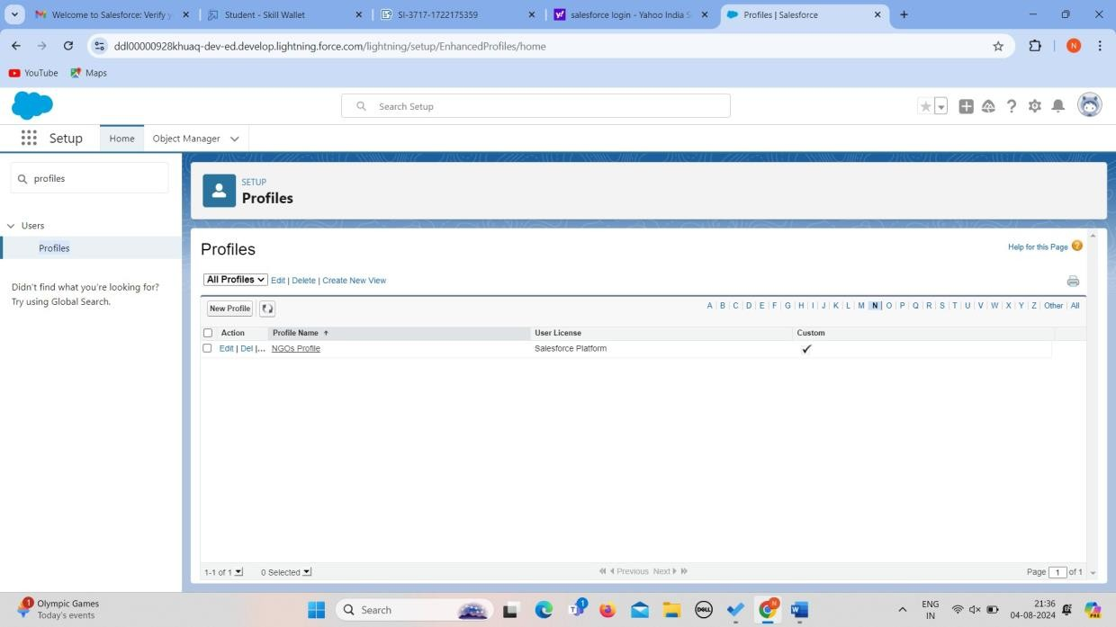

## TASK 9 : Creationof Users

In our Projectwe consider them as NGO’s

### Creation of User1

1. Go to setup page >> type users in Quick Find bar >>click on users>> New user.
2. In GeneralInformation give detailsas: (Note : create users as per your wish NGO’s)

First Name : Iksha Foundation Last Name : Iksha_Foundation Alias : iiksh

Email : Give Your Email

Username : [ikshafoundation@sb.com](mailto:ikshafoundation@sb.com) (give the username different) Nickname : Auto Populated

User License : Salesforce Platform Profile :

NGOs Profile Active : Check

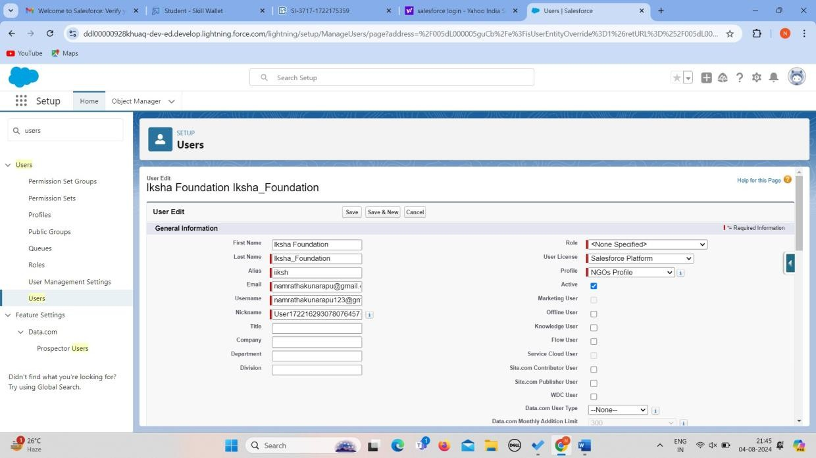

1. Click on Save

### Creation of User2,User3

Create another Two Usersby following steps in Activity- 1 with similar User License and Profile.

Give DifferentFirst Name, Last Name based on Different NGO’s.

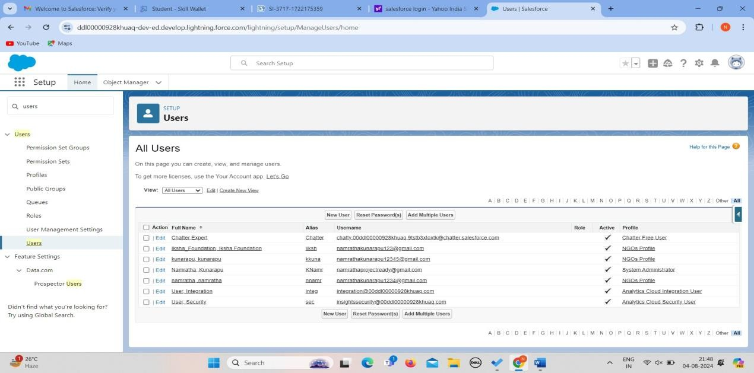

## TASK 10:Public Groups

### Creation of PublicGroup 1

1. Go to setup page >> type Public Groups in QuickFind bar >>click on PublicGroups >> click on New.
2. Under Group Information: Label : Iksha

Group Name : Iksha

Grant Access Using Hierarchies : Check

1. In Search, Select Users.
2. In Selected Members Add Iksha Foundation and SystemAdministrator

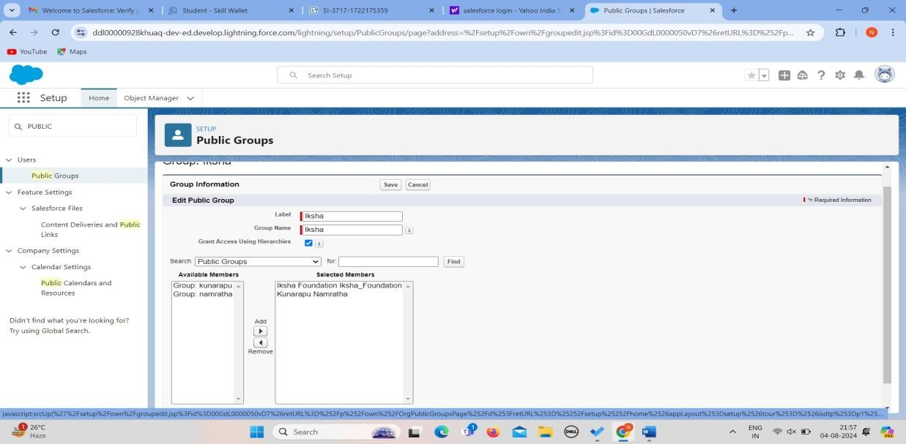

### Creation of PublicGroup 2

1. By Following Steps in Activity 1, Create other two PublicGroups for other two users.
2. After Saving thiswould look like this.

|  |  |
| --- | --- |
|  |  |
|  |  |

## TASK 11: Report Types

### Creation of ReportTypes

1. Go to setup page >>type Report Types in Quick Find bar >> click on Report Types >>click on Continue >> Click on New Custom Report Type.
2. In Define the Custom Report Type: Primary Object :Select Venues

Report Type Label : Venue with DropOff with Volunteer

Report Type Name : Venue_with_DropOff_with_Volunteer Description : Venue with DropOff with Volunteer

Store in Category : Select Other ReportsDeployment Status : Deployed

1. Click on Next
2. Near Click to relate another Object Select Drop-OffPoints.
3. And also select "A" records may or may not have related "B" records.
4. Now again Near Click to relateanother Object Select Volunteers.

|  |  |
| --- | --- |
|  |  |
|  |  |

1. Now click on Save.

## TASK 12:Reports

### Creation of Reporton Venue with DropOff with Volunteer

1. Go to the app(FoodConnect) >>click on the reports tab
2. Clickon New Folder.

Folder Label : Custom Reports

Folder Unique Name : CustomReports

1. OpenCustom Reports and click on New Report
2. Select Report Type: Venue with DropOff with Volunteer
3. Then click on StartReport.
4. InGROUP ROWS : Add Volunteer Name
5. In Columns : Add Venue Name, Drop-Offpoint Name, Distance.
6. Nowclick on Save & Run.
7. GiveLabel as :
8. Report Name : venue and Drop Off point
9. Report Unique Name : Auto Populated
10. Click on Select Folder and selectCustom Report, then click on Save.

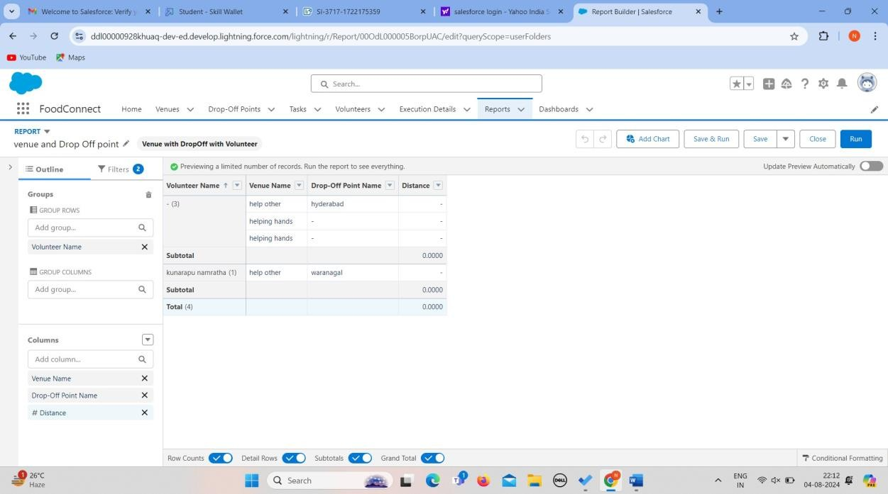

### Creation of Reporton Volunteers with Execution Detailsand Tasks

1. Go to the app(FoodConnect) >> click on the reportstab
2. Click on Custom ReportsFolder and clickon New Report
3. Select Report Type : Volunteers with Execution Detailsand Tasks.
4. Then click on Start Report.
5. In GROUP ROWS : Volunteer ID
6. In Columns: Add Volunteer : Volunteer Name, Task : Task Name, Execution Detail : Execution Detail Name, Volunteer: Owner Name, Task: Date, Task : Rating.
7. Nowclick on Save & Run.
8. GiveLabel as :

Report Name : Volunteer Task

Report Unique Name : Auto Populated

1. Click on Select Folder and selectCustom Report, then click on Save.

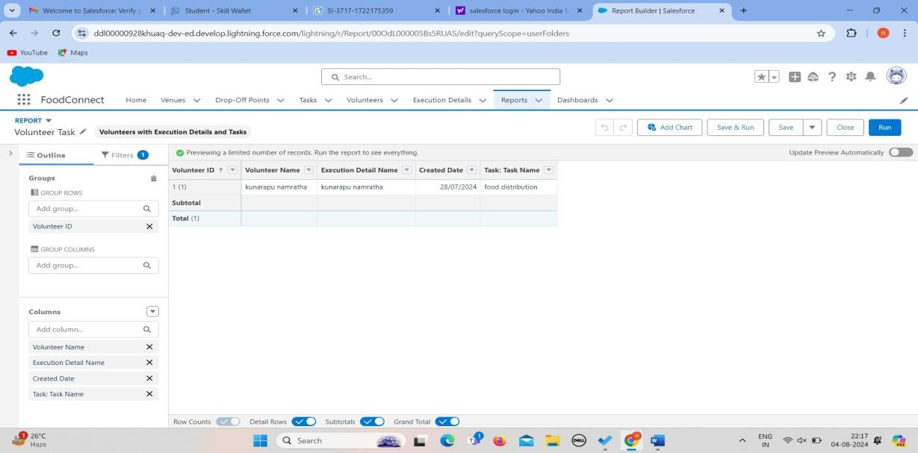

## TASK 13:Dashboards

### Adding venue and Drop Off point Report to the Dashboard

1. Go to the app(FoodConnect) >> click on the Dashboards tab.
2. Click on New Folder.

Folder Label : Custom Dashboards Folder UniqueName : Auto Populated

1. Open Custom Dashboards and click on New Dashboards
2. Name : Organization Details
3. Click on Widget and select Chart or Table
4. In SelectReport : Selectvenue and Drop Off point Report.
5. Then click on select
6. In Add Component:

Display As : Select Lightning Table Component Theme : Select Dark (Optional)

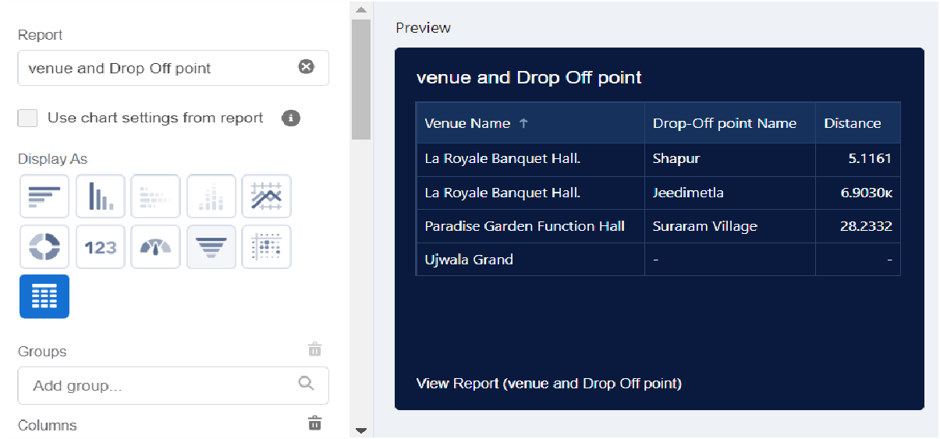

Now click on save.

### Adding Volunteer Task Report to the Dashboard

1. Click on Widget and select Chart or Table
2. In Select Report : Select Volunteer Task Report.
3. Then click on select
4. In Add Component:

Display As : Select Line Chart

Component Theme : SelectDark (Optional)

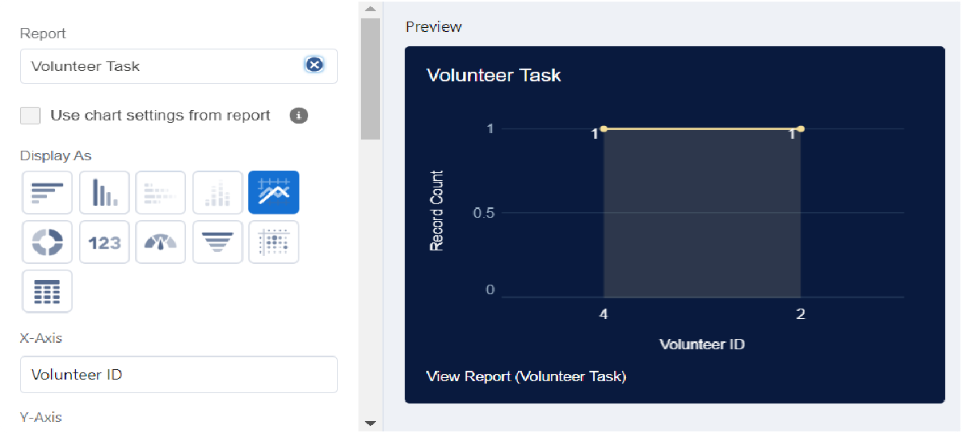

Now click on save.

### Adding a Pictureto the Dashboard (Optional):

(Note : To upload an image into the Dashboard, we have to first downloadan image from googleor other sources into your system)

1. Click on Widget and select Image. Then clickon Browse Files.
2. Then Select the Picture you want to upload in this Dashboard.
3. Then clickon Save As :

Name : Task Execution Details

Click on SelectFolder and select Custom Dashboards

1. Clickon Select Folderand then Save.

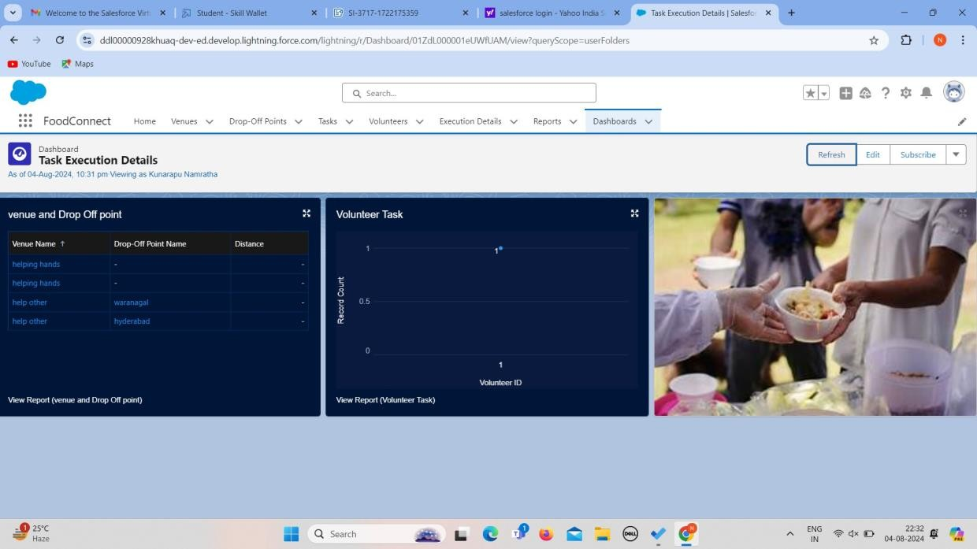

## TASK 14: Sharing Rules

### Creation of sharing rules

1. Go to setup >>type Sharing Settingsin quick find box >>Click on the Sharing Settings.
2. Scroll down and find Drop-Off point Sharing Rules.
3. Click on new near Drop-Off point Sharing Rules and Name it as: Label : Rule 1

Rule Name : Rule_1

1. Select your rule type : SelectBased on criteria.
2. Select which records to be shared:

Field : Operator: Value = Distance : less than : 15

1. Select the users to share with : Near Share WithPublic Groups : Iksha
2. Clickon Save.
3. Click on new near Drop-Off pointSharing Rules and Name it as:

Label : Rule 2

Rule Name : Rule_2

1. Select your rule type : SelectBased on criteria.
2. Select which records to be shared:

Field : Operator: Value = Distance : greater than : 15 Field : Operator : Value = Distance : less or equal : 30

1. Select the users to share with : Near Share WithPublic Groups : NSS
2. Clickon Save.
3. Click on new near Drop-Off point Sharing Rules and Name it as: Label : Rule 3

Rule Name : Rule_3

1. Select your rule type : SelectBased on criteria.
2. Select which records to be shared:

Field : Operator: Value = Distance : greater than : 30 Field : Operator : Value = Distance : less or equal : 50

1. Select the users to share with : Near Share WithPublic Groups : Street Cause

|  |  |
| --- | --- |
|  |  |
|  |  |

1. Click on Save.

# TASK 15:HomePage

### Creation of Home Page

1. Go to setup >>type Lightning App Builder in quick find box >>Click on the Lightning App Builder and Select the New.
2. Select Home Page and give Label as HOME Page.
3. Select Standard Home Page.
4. Near Components search for Flow and Drag and Drop in Right Side Section..
5. On the right handside:

Flow : Venue Flow

1. Near Components search for Dashboard, then Drag and Drop it in firstSection.

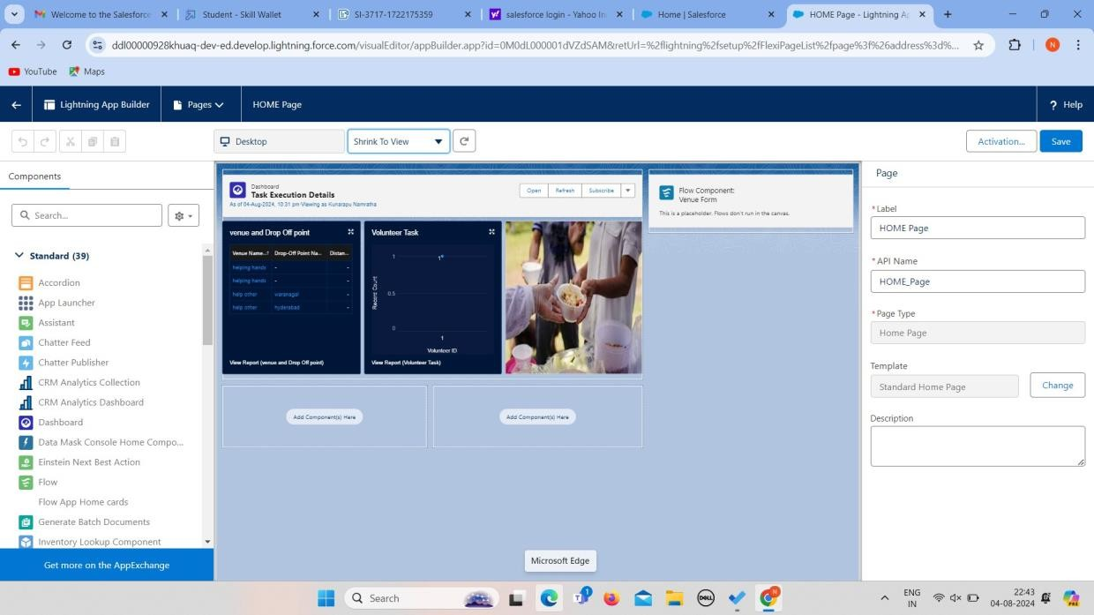

1. Click on Save and Activation, then click on App Default,then Add Assignments.
2. Add FoodConnect App and then Save.
3. FoodConnect Home Page would Look Like this.

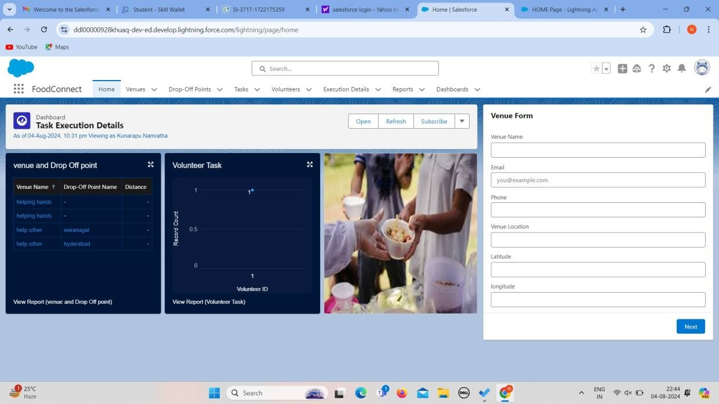

**Conclusion**

By leveraging the Salesforce platform, the project successfully established a streamlined and transparent system for managingsurplus food donations. Through efficient coordination with volunteers and timely delivery to beneficiaries, the project effectively addressed food insecurity while maximizing the utilization of available resources.

|  |  |
| --- | --- |
|  |  |
|  |  |